# CS 255 System Design Document Template

## UML Diagrams

### UML Use Case Diagram

### UML Activity Diagrams

### UML Sequence Diagram

### UML Class Diagram

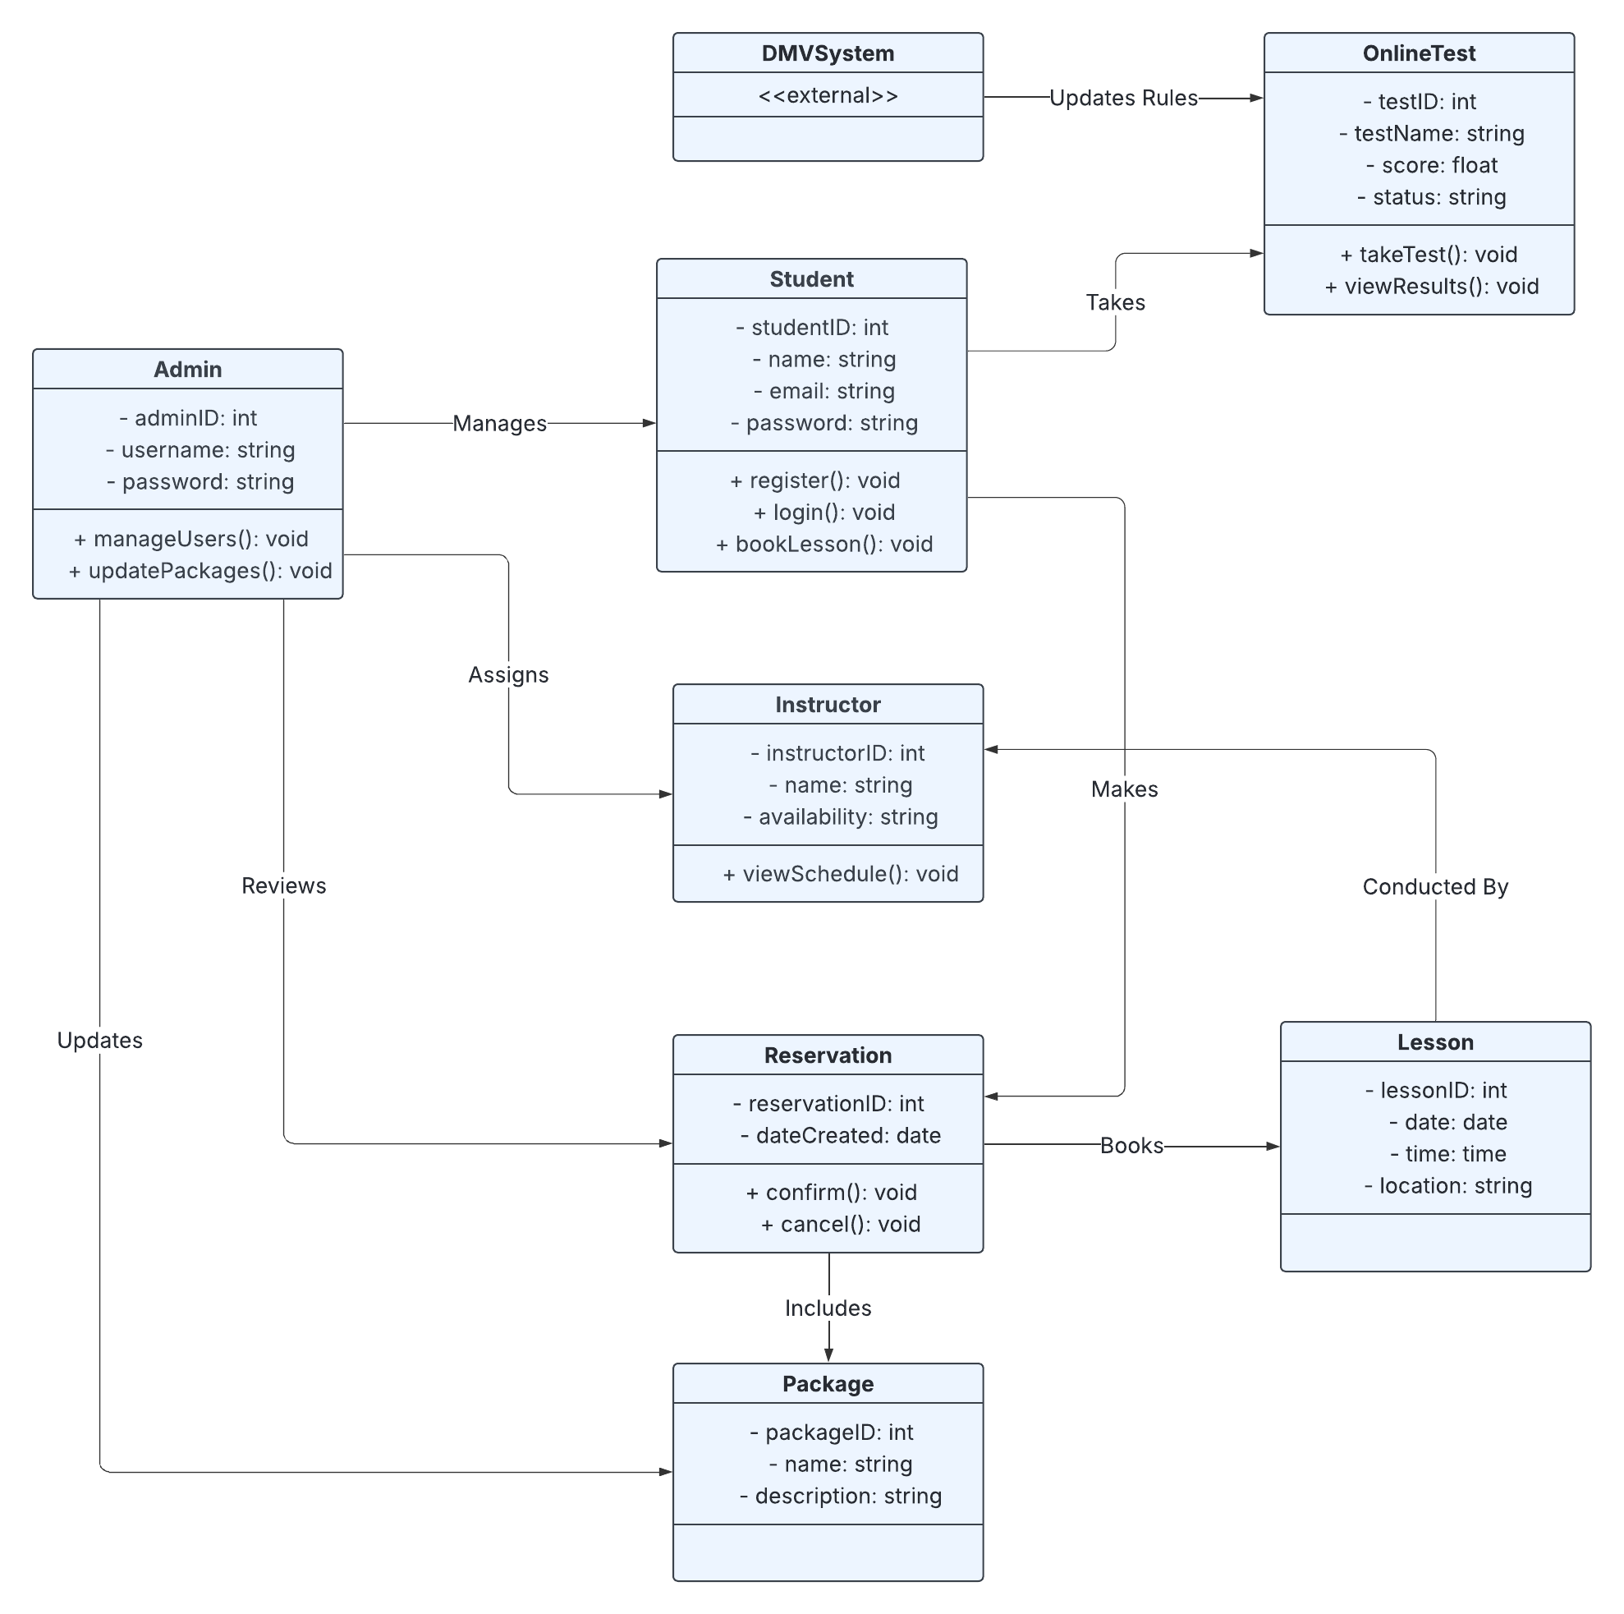

## Technical Requirements

**Hardware Requirements**

* A cloud-hosted virtual server (e.g., AWS EC2 or Azure VM) for running the backend application
* Reliable cloud infrastructure with high availability (99.9% uptime SLA recommended)
* Mobile-responsive web access for smartphones, tablets, laptops, and desktops
* Optional barcode or ID scanner for on-site identity verification during training

**Software Requirements**

* Web-based frontend using HTML5, CSS, and JavaScript (React or Angular optional)
* Backend application using Java, Python (Django), or Node.js
* Relational Database Management System (RDBMS) such as PostgreSQL or MySQL
* RESTful API for DMV integration to fetch live updates for rules and tests
* User authentication and session management modules
* Third-party payment gateway integration (e.g., Stripe, PayPal)

**Development and Modeling Tools**

* Lucidchart for UML modeling and system visualization
* GitHub or GitLab for source code version control
* IDE such as IntelliJ IDEA, VS Code, or PyCharm
* Postman or Swagger for API testing and documentation

**Infrastructure & Deployment**

* Hosted on a scalable cloud platform such as AWS, Google Cloud, or Azure
* HTTPS support with SSL certificates for secure data transmission
* Daily backup and disaster recovery protocols
* Logging and monitoring tools (e.g., AWS CloudWatch, Datadog, or ELK stack)
* CDN support for fast content delivery to global users

**Security Requirements**

* Role-based access control (RBAC) for Student, Admin, Instructor, and Secretary roles
* Password hashing (e.g., bcrypt) and encrypted tokens for session handling
* Multi-factor authentication (MFA) for Admins and IT personnel
* Automatic account lockout after multiple failed login attempts
* Activity logging for auditing purposes (e.g., lesson changes, test scores)
* Secure data storage policies (especially for personally identifiable information and payment data)